Dynatrace Host Configuration steps:

1.Login Dynatrace or sign in Dynatrace with account.

2.Select Hosts under the infrastructure Section

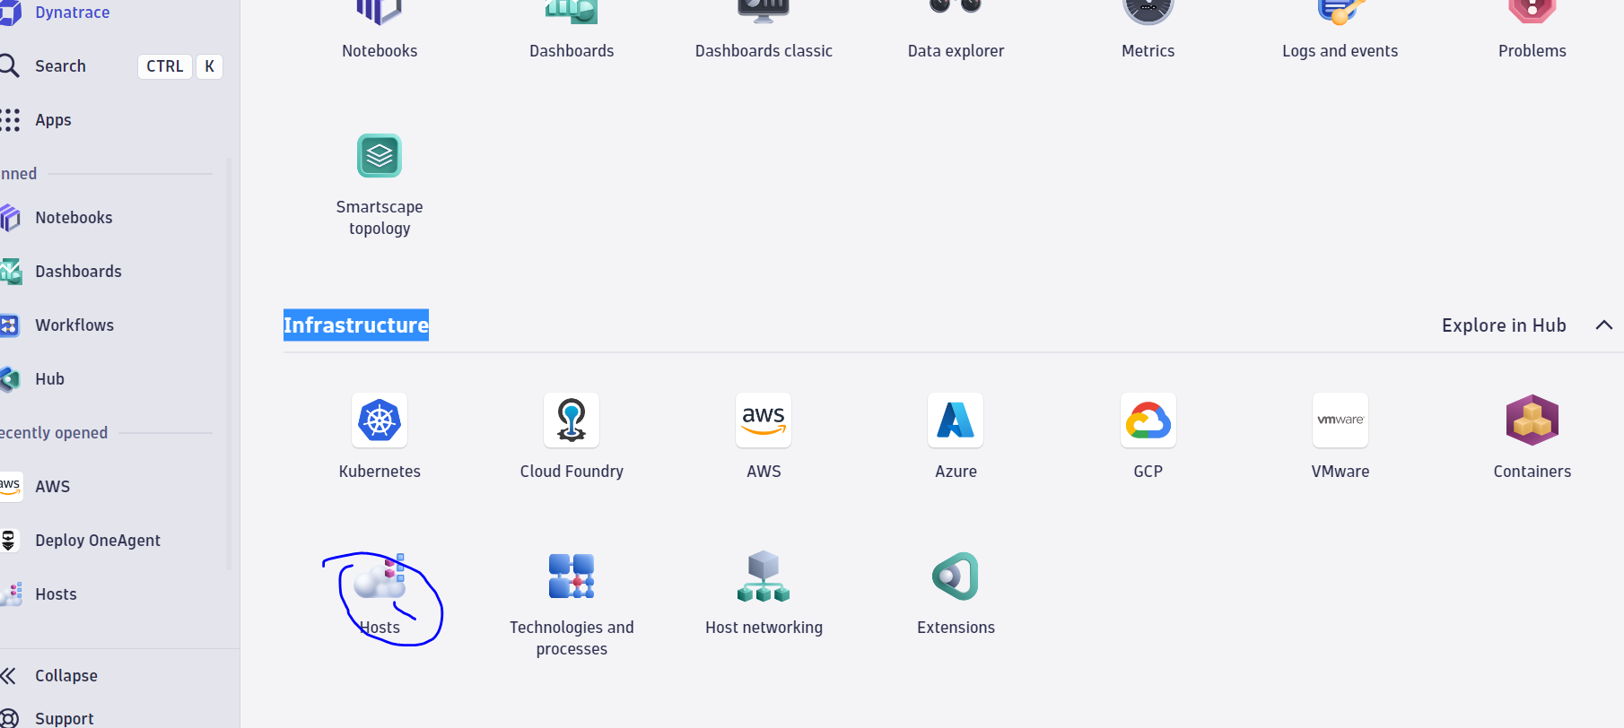

3.Select Delpoy Dynatrace after selecting Hosts

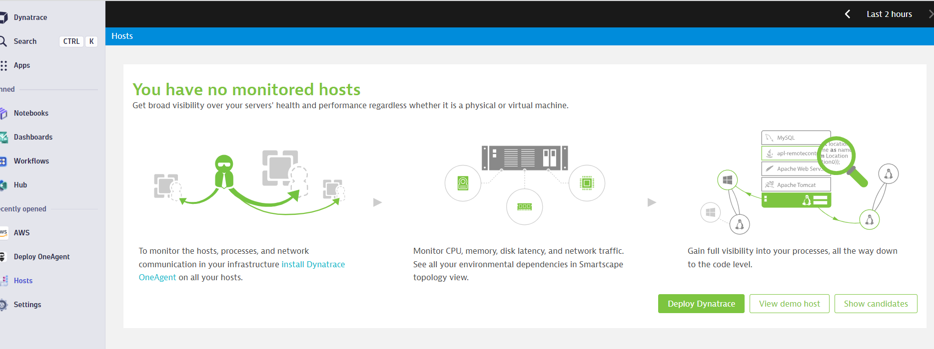

4.After getting Dynatrace page selecting the one agent

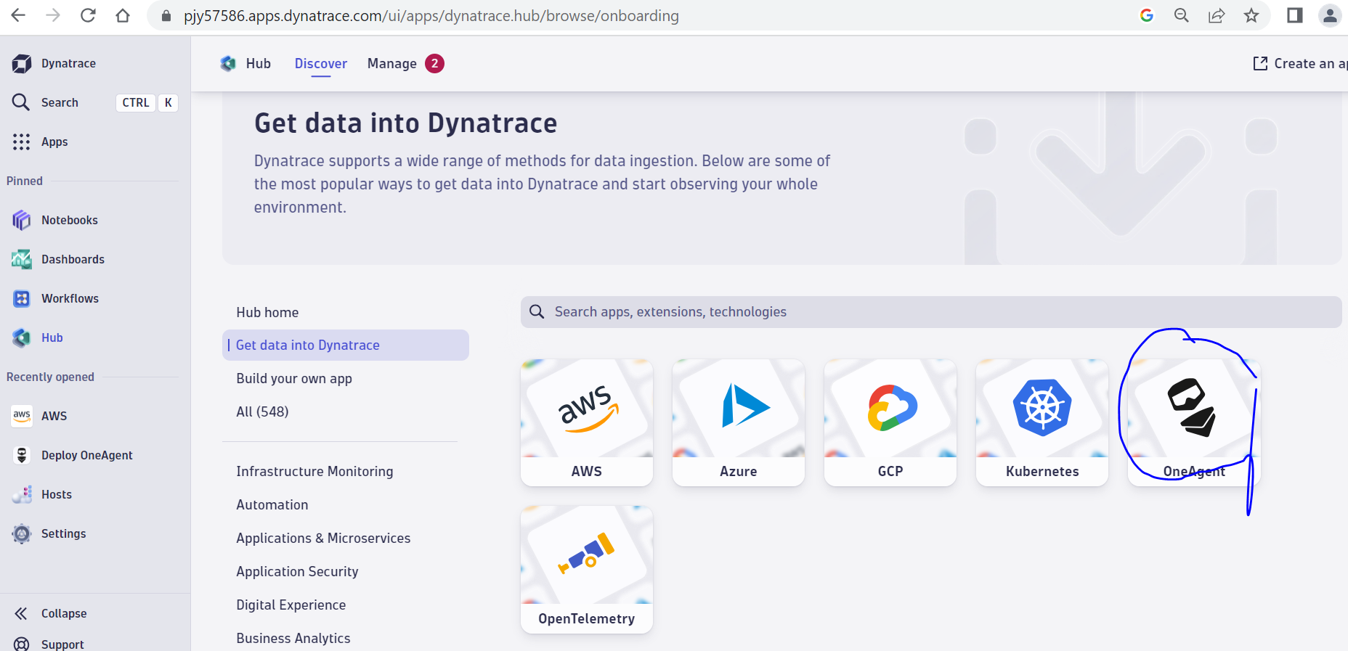

5.Select the Setup button.

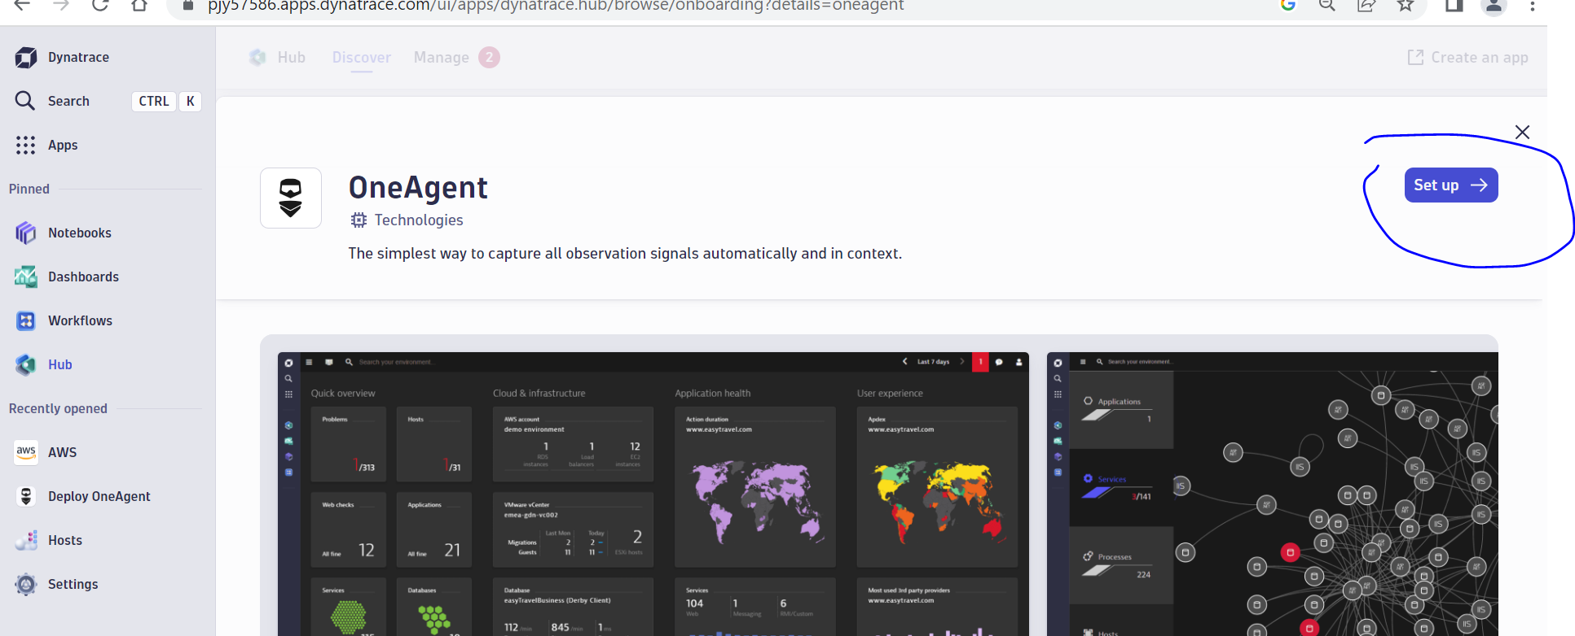

6.Select the platform

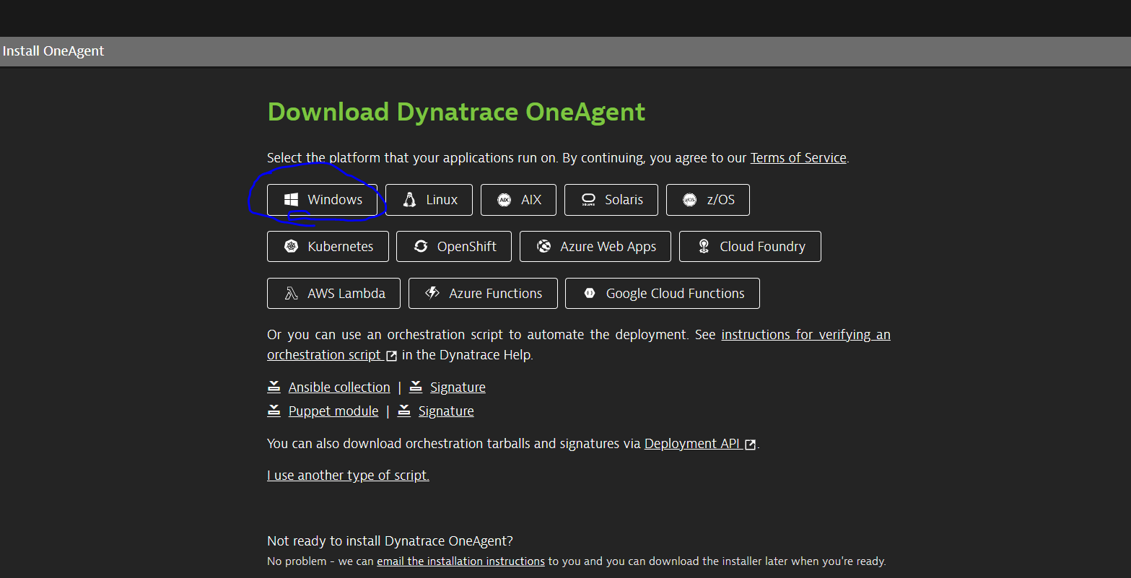

7.We select setup then we generate the token

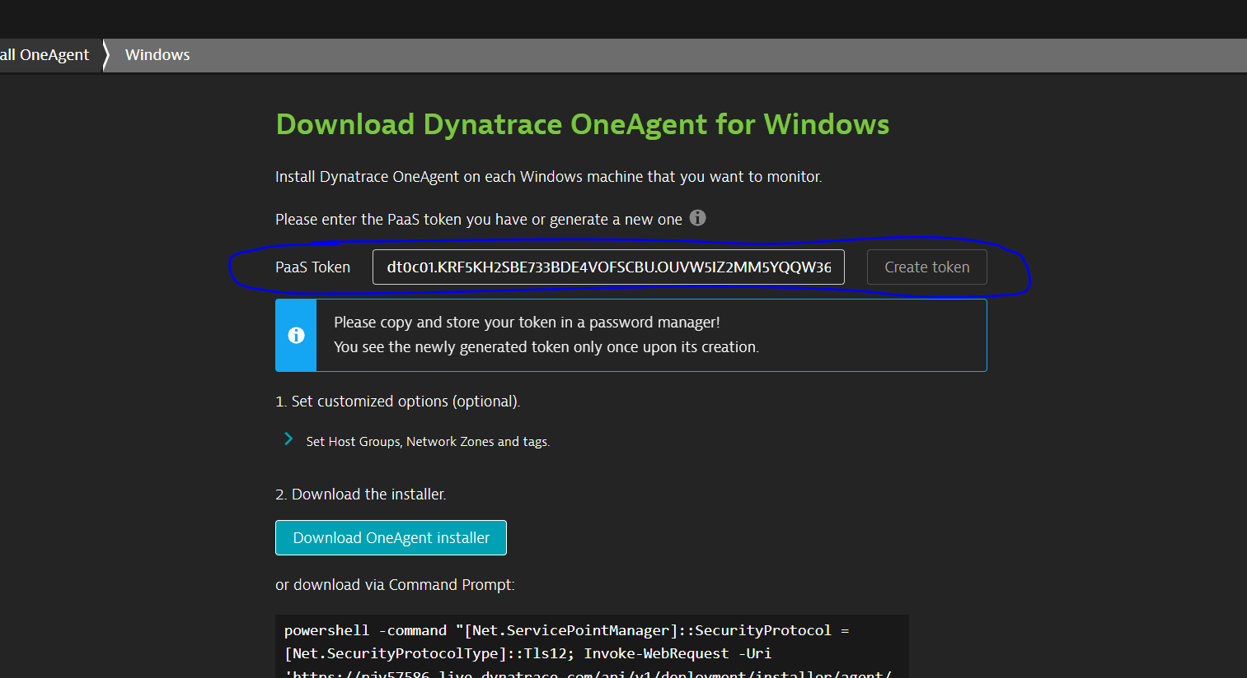

8.Then download the one agent using Powershell command

9.Downloded using shell command in windows virtual machine

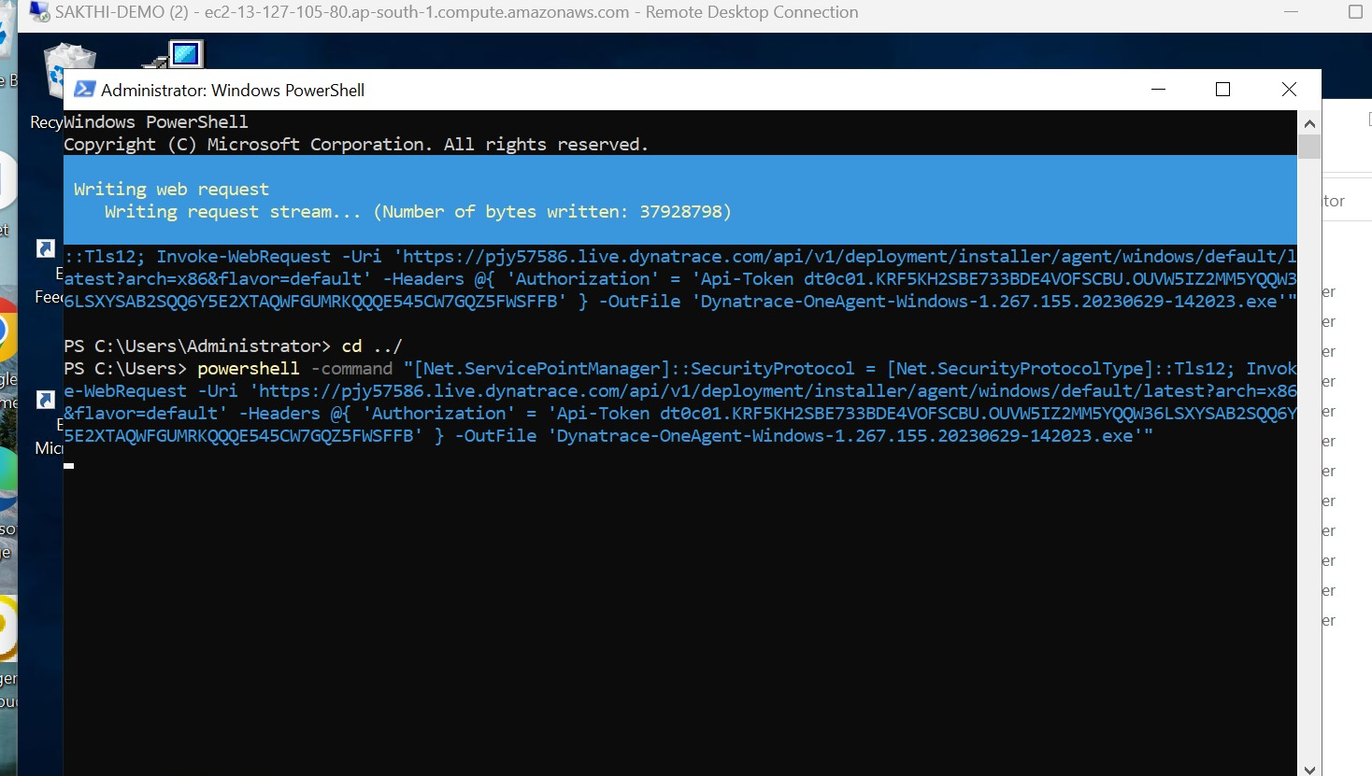

10.Run the installer using this command

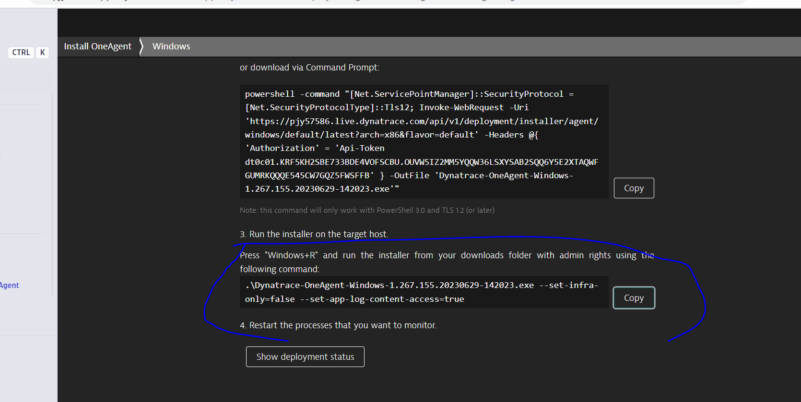

11.Once Completed the installation click on show deployment status



11.After click on Show deployment status we can able to see the our instance in Dynatrace.

